Papers written by
Australian Maths Software

REVISION 2
2016

SEMESTER 2

MATHEMATICS
APPLICATIONS
Units 1 & 2

SOLUTIONS

SECTION 1 – Calculator-free
Question 1 (4 marks)
(a) 4 + 12 + 3 = 19 cm

(b)

The diagonal route is 6 cm shorter.

Question 2 (4 marks)

(a) $10x4 + $30x8x4 = $40 + $960 = $1000

(b) Shop
Shop price is $16.20
Online is $16
Cheaper to buy online by 20 cents.

Question 3 (6 marks)
(a)

(b) -1/error

(c) -1/error

Question 4 (20 marks)
(a) (i)
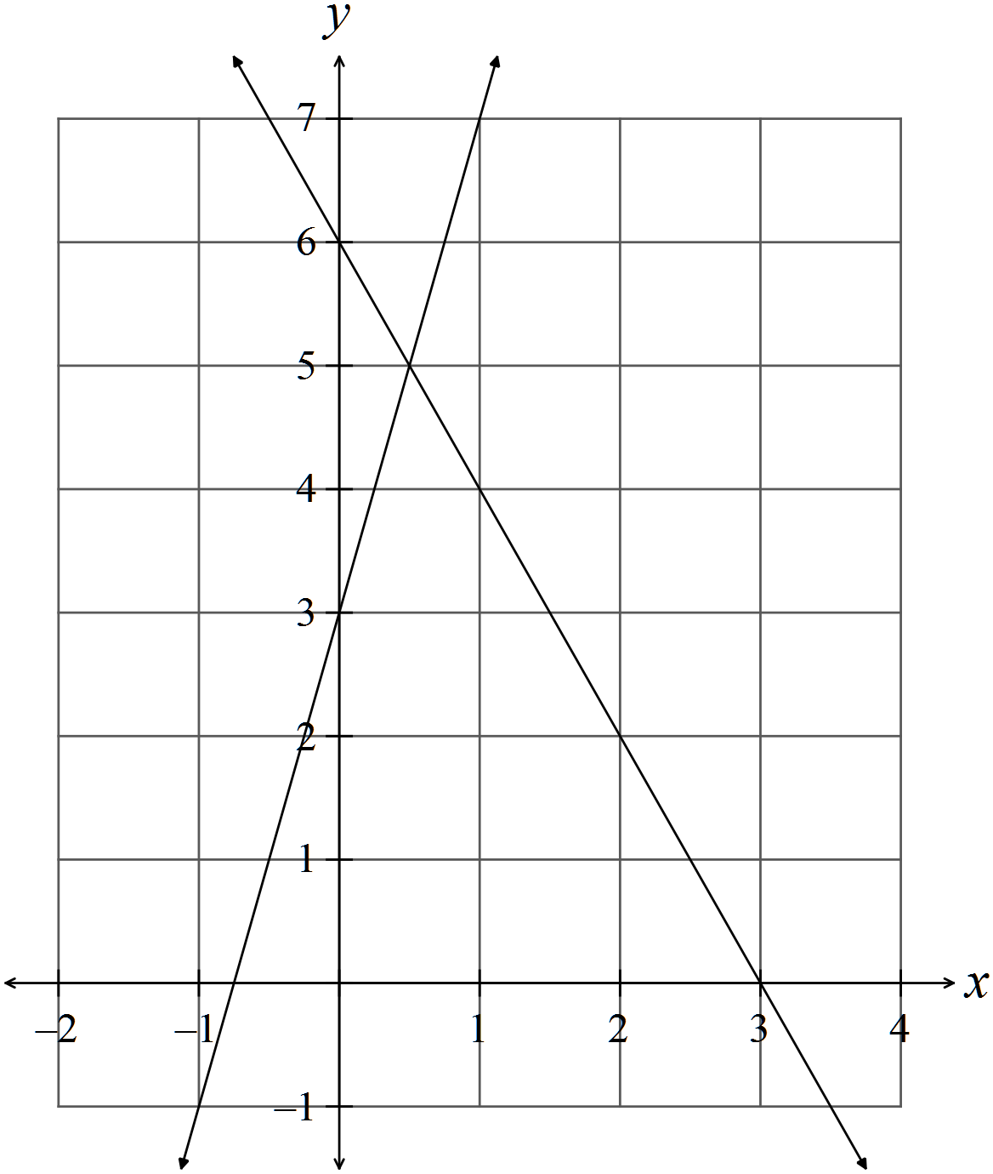
(ii)
(iii)
This confirms the point of intersection.

(b)

(c)

(d)

OR

Question 5 (12 marks)

(a) (i)

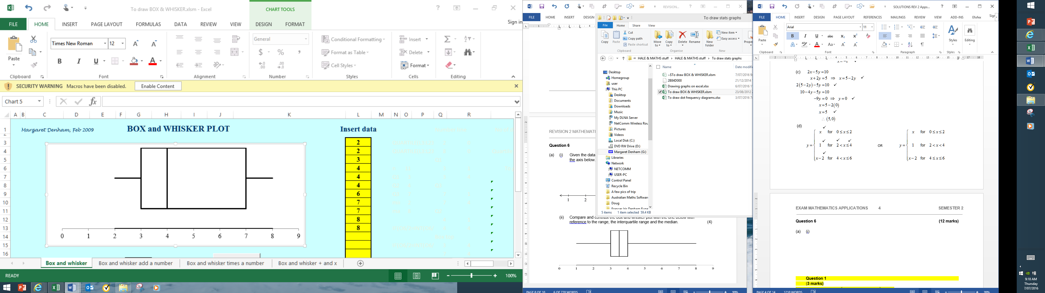

(ii)

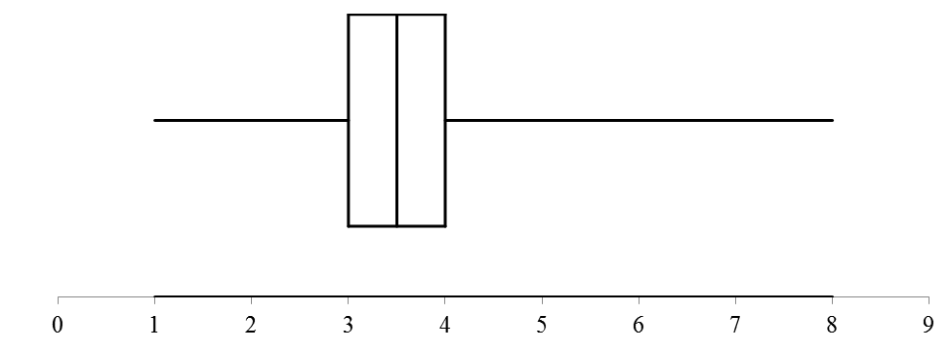

Box plot 1 has a range of 8 - 2 = 6 and IQR = 7- 3 = 4.

Box plot 2 has a range of 8 - 1 = 7 but a much more highly clustered middle 50% with
the IQR = 4- 3 = 1.

The medians are similar 4 and 3.5.

Data 2 may well have an outlier at 8. The ranges are similar.
Data 1 is skewed as 25% of the scores are between 3 and 4 and the next 25% of scores
are between 4 and 7.

(iii) On a box and whisker plot, the individual scores are not seen so the standard
deviation cannot be determined.

(b)
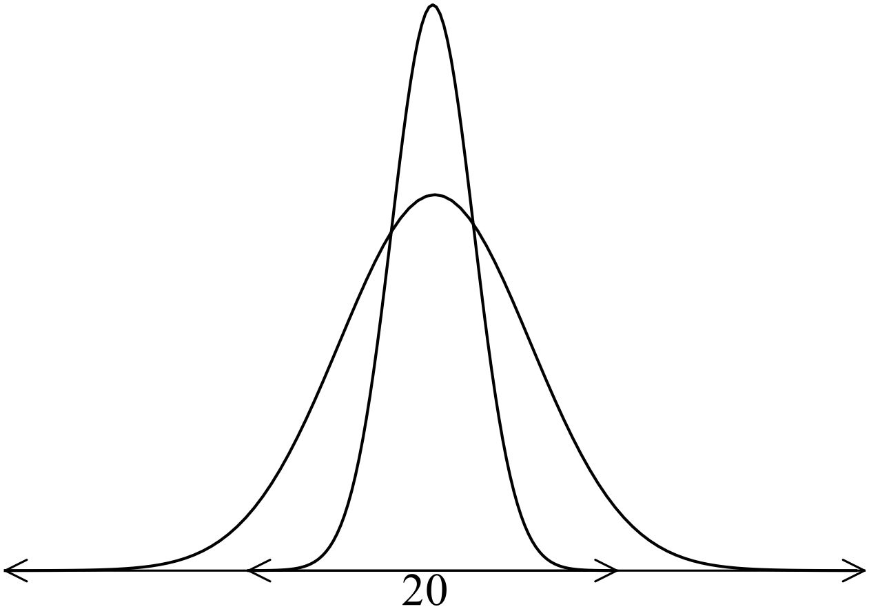
Question 6 (6 marks)

(a) “Income level” is ordinal aso income levels can be ranked.

(b)
Score | Frequency
2 | 4
3 | 1
4 | 3
5 | 0
6 | 1
7 | 2
8 | 3

(c) The data is tightly clustered and skewed to the right.
The mean of the distribution is higher than the median as it is pulled higher by the
extreme scores to the right.

END OF SECTION ONE

SECTION 2 – Calculator-assumed
Question 7 (6 marks)
(a)
(b) (i) -1/error
(ii)
There were 75 people served.

Question 8 (11 marks)
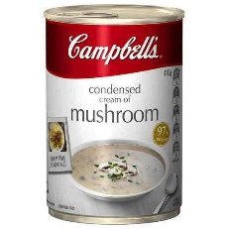
(a)

The 420 gram for $195 is the cheaper.

(b) (i)

(ii)

(c) Profit

Question 9 (3 marks)

Question 10 (20 marks)

(a)
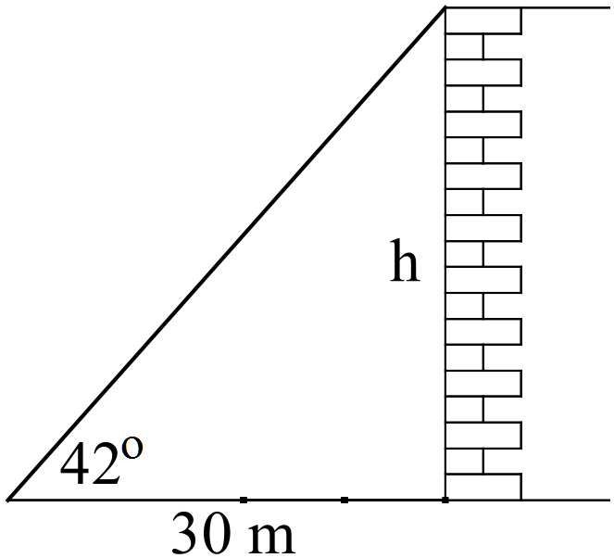

(b) (i)

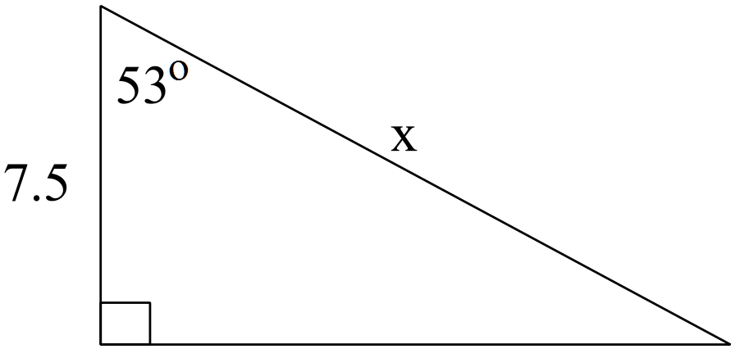

(ii)

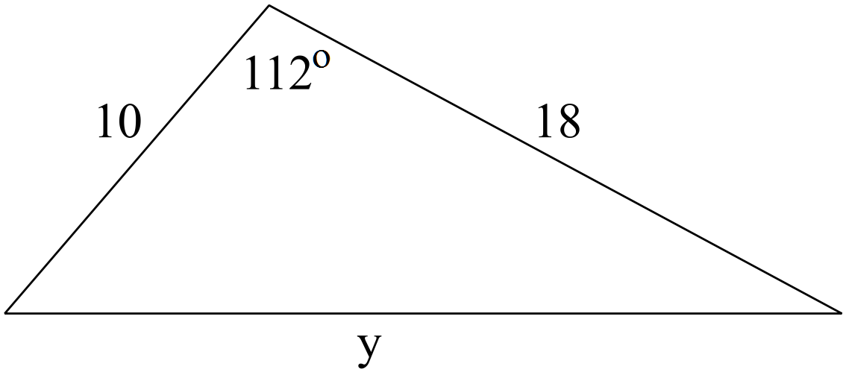

(iii)
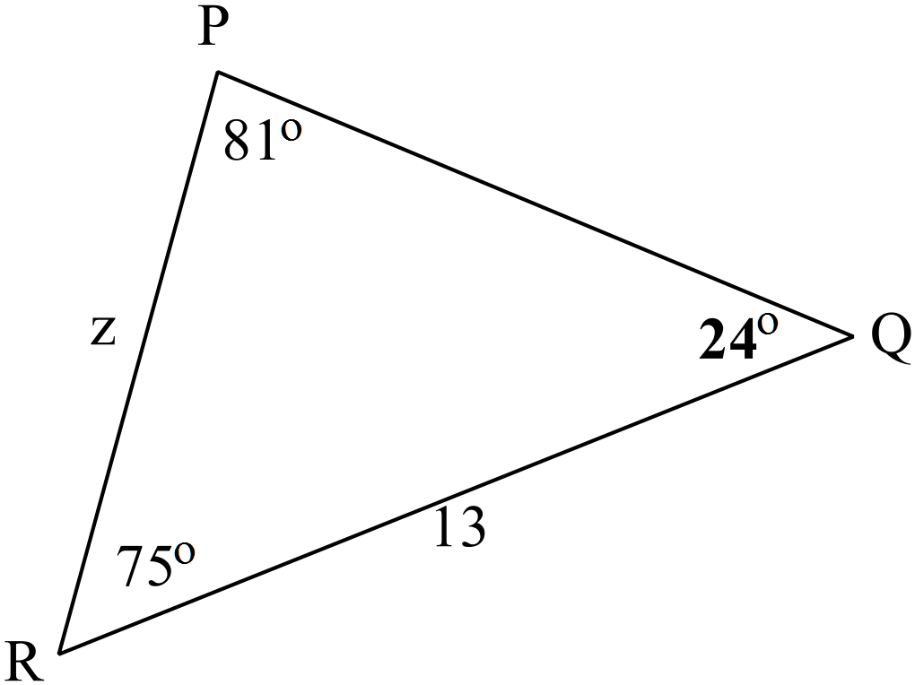

(c)
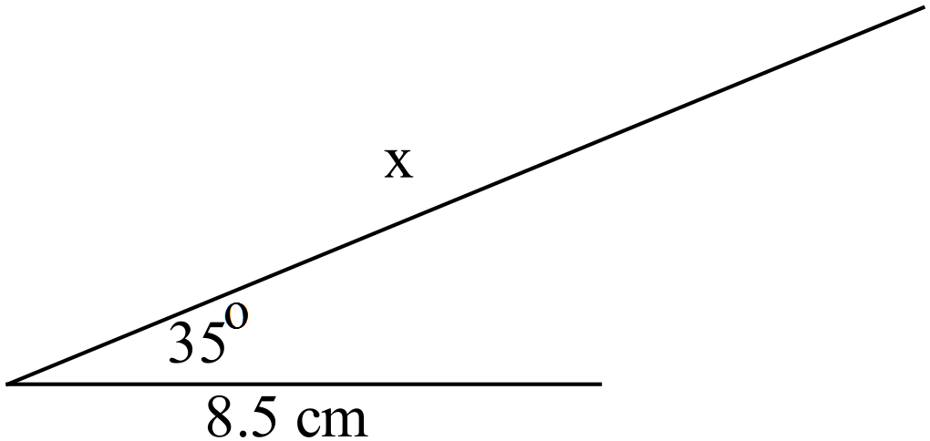
(i)

(ii)
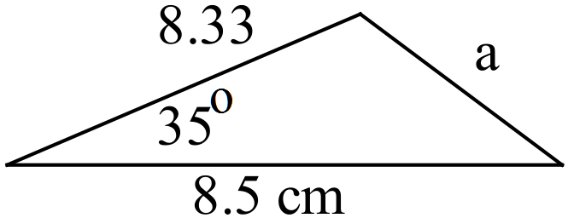

(d) (i)
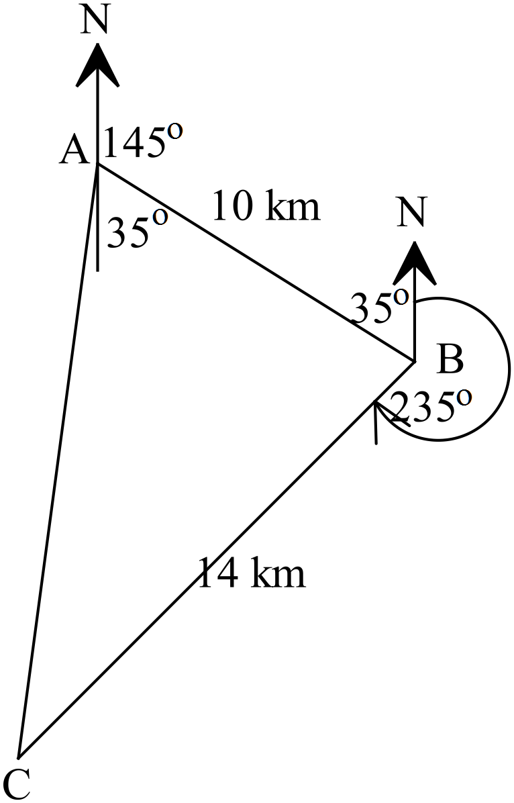

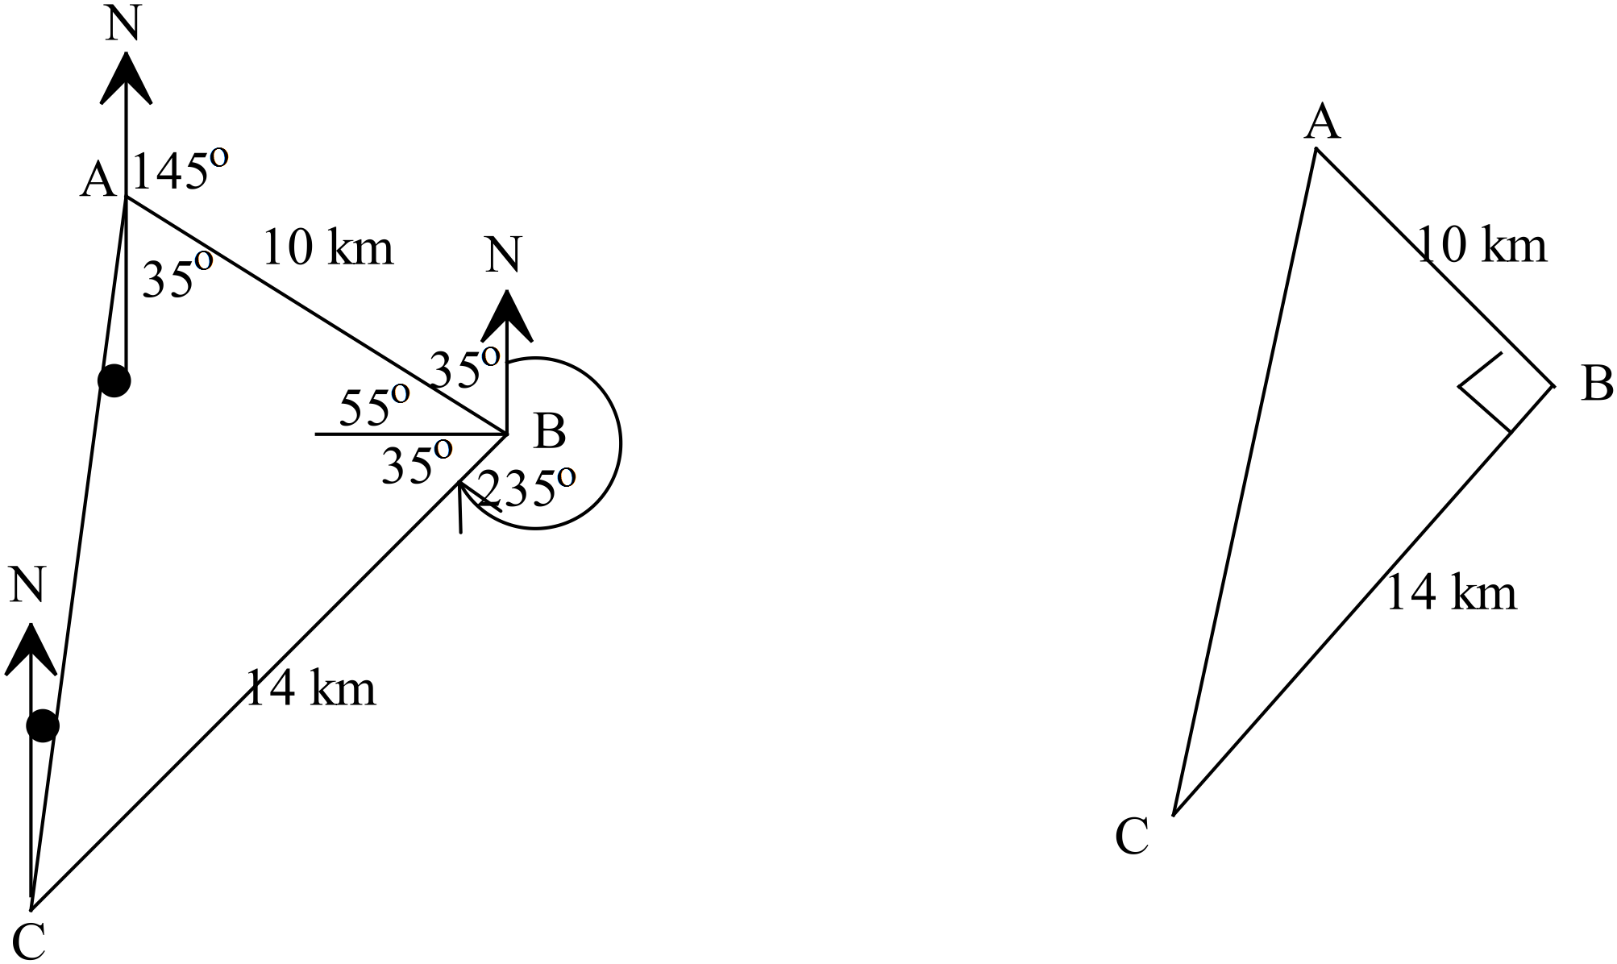 (ii)

The direction to the starting point is 019.5º

(iii)

Question 11 (9 marks)

(a)

(b)
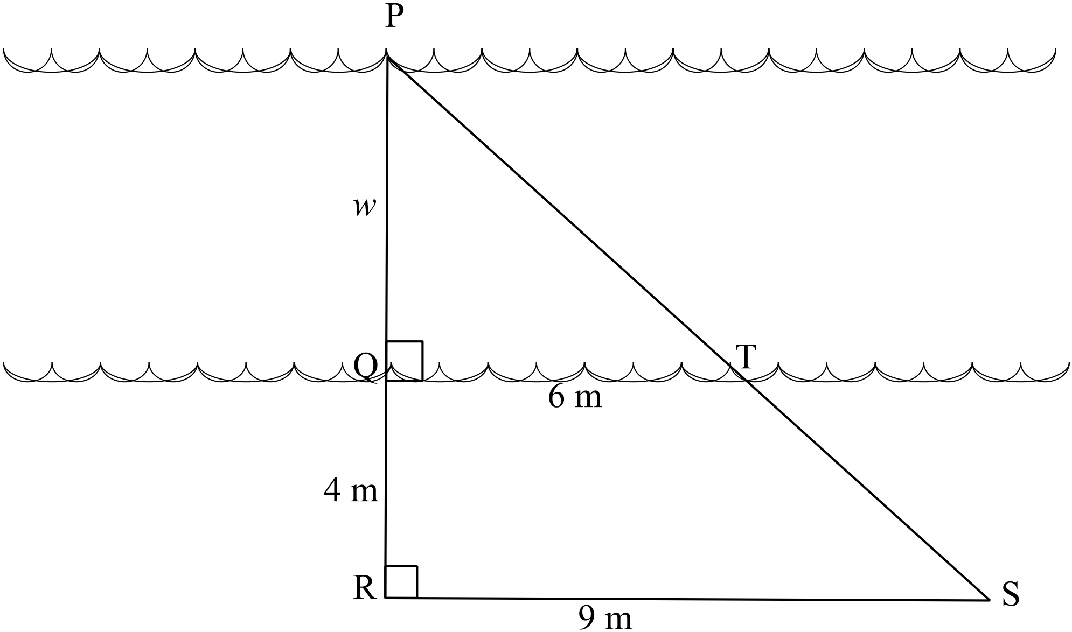
(i) In triangles PQT and PRS,

(ii)

The river is 8 metres wide.

Question 12 (9 marks)
(a)
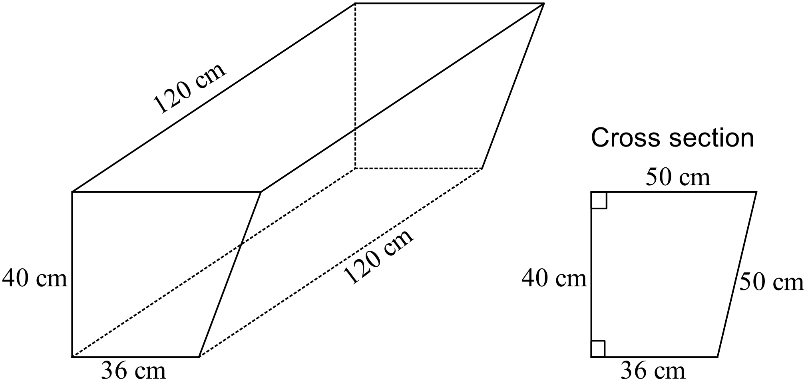

Area of the end

Volume

(b)
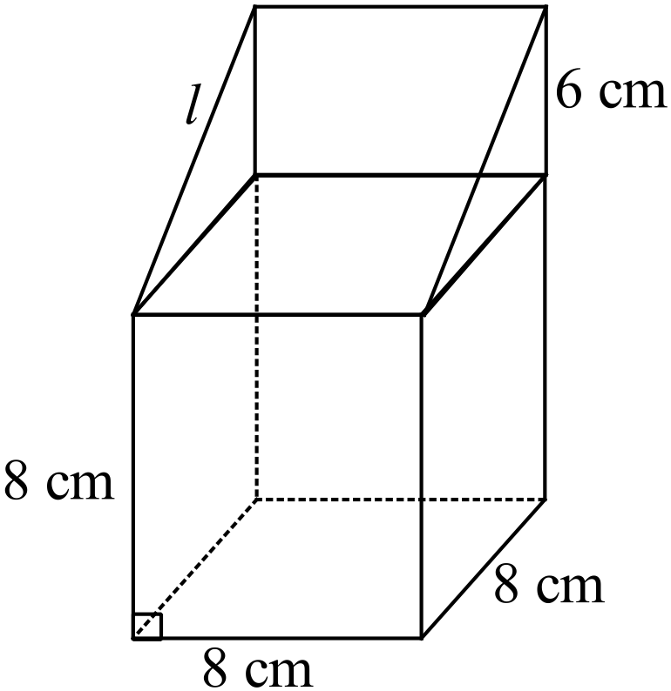
(i)

(ii)

(iii) Enlarged volume =

Question 13 (18 marks)
(a) (i)
(ii)
(iii)
(iv) P(the lightest weight of the heaviest 70 % of the breed) = 6.32 kg
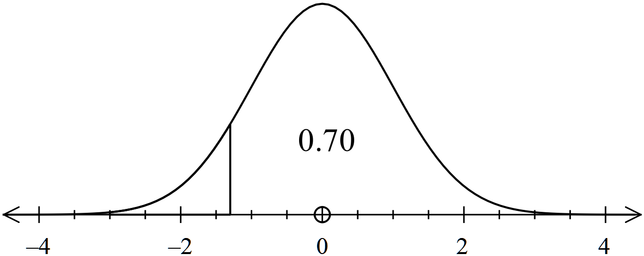

(b) Weight 0 sd
Height 1.95 sd above the mean
Chess 1.95 sd above the mean
Football 2.7 sd below the mean

(c)

Question 14 (11 marks)

(a) (i) 3,3,3

(ii) 9,10,11 answers may vary

(iii)

(b)
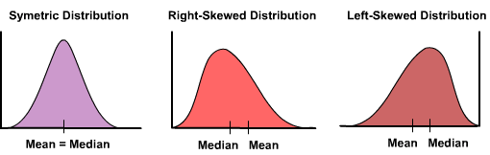

Mean of 10
Median of 12

Median of 8
Mean of 10

The two sets of data have identical distributions, but one is a reflection of the other.
Both are skewed with the mean away from the median (and distorted by the extreme
scores).

Question 15 (9 marks)

(a)
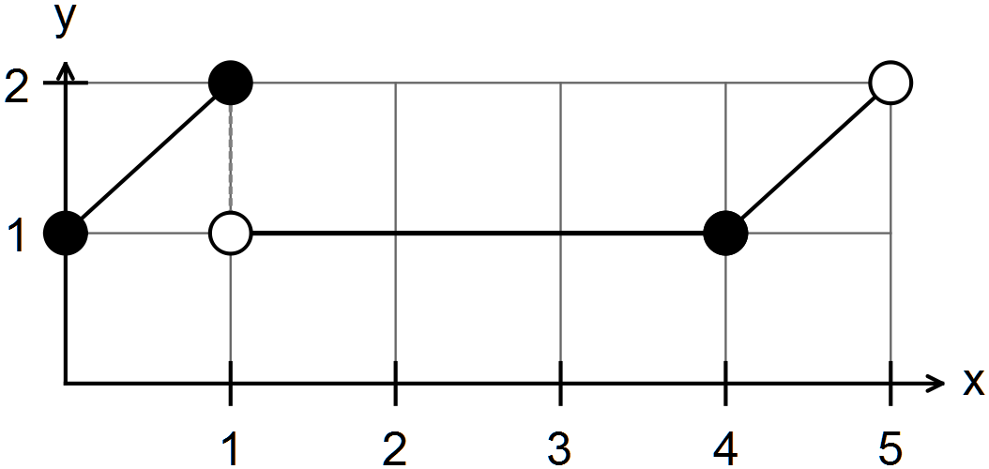

(b) Let x = price of CD players
Let y = price of electric toothbrushes

Therefore CD players cost $130 and electric toothbrushes cost $70.
End of solutions

